Geography AS / A level
Additional Reading

The Sixth Extinction by Elizabeth Kolbert

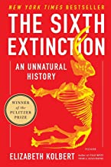

An uninhabitable earth by David Wallace-Wells

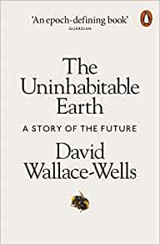

Adventures in the Anthropocene: A Journey to the Heart of the Planet We Made by Gaia Vince

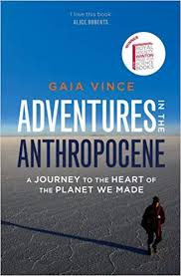

When the rivers run dry by Fred Pearce

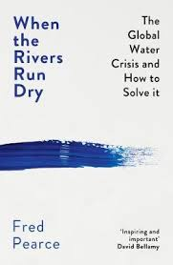

The Story of Earth: The First 4.5 Billion Years, from Stardust to living planet
by Robert Hazen

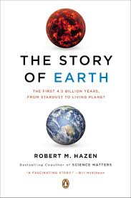

The Ripple Effect: The Fate of Fresh Water in the Twenty-First Century by Alex Prud'homme

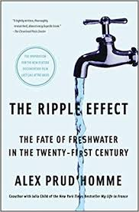
Factfulness by
Hans Rosling
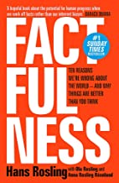

The Almighty Dollar by
Dharshini David
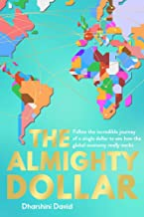

Inequality and the 1%
By Danny Dorling

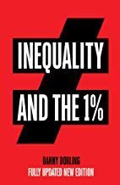

Injustice by Danny Dorling
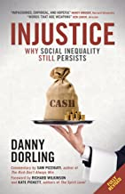

Peak Inequality
By Danny Dorling
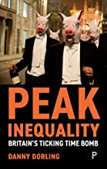

Infections and Inequalities: The Modern Plagues
by Paul Farmer
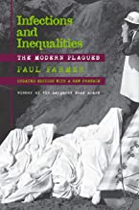

The Windrush Betrayal by
Amelia Gentlemen
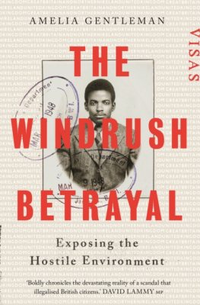

The Good Immigrant by
Nikesh Shukla
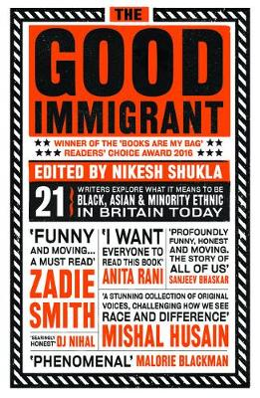
The Last Girl by Nadia
Murad
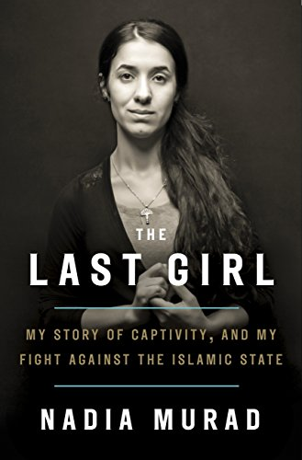

Not Human Enough by
Samuel Moyn
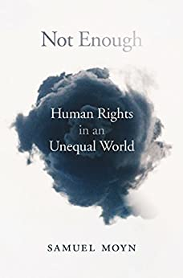

The Fever: How Malaria Has Ruled Humankind for 500,000 Years
By Sonia Shah
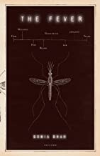

House on Fire: The Fight to Eradicate Smallpox by Bill Foege
