Subject and Exam Board: A-level Physics OCR A.
Syllabus no. H556
Web link: https://www.ocr.org.uk/qualifications/as-and-a-level/physics-a-h156-h556-from-2015/
Minimum Entry Requirement at GSCE: Level 6 in Physics or Grade 7-7 or above in Combined Science, plus minimum Grade 6 in Mathematics
Head of Subject: Mr Mathison
Course Description
OCR’s A Level in Physics A specification aims to encourage learners to:
- develop essential knowledge and understanding of different areas of the subject and how they relate to each other
- develop and demonstrate a deep appreciation of the skills, knowledge and understanding of scientific methods
- develop competence and confidence in a variety of practical, mathematical and problem-solving skills
- develop their interest in and enthusiasm for the subject, including developing an interest in further study and careers associated with the subject
- understand how society makes decisions about scientific issues and how the sciences contribute to the success of the economy and society (as exemplified in ‘How Science Works’ (HSW)).
- Prepare students for higher and other educational establishments and for professional courses which require candidates to have a knowledge of physics when admitted.
- Practical activities are embedded within the learning outcomes of the course to encourage practical activities in the classroom which contribute to the achievement of the Practical Endorsement.
What you will learn in Year 12 | What you will learn in Year 13
Module 1:  Development of practical skills in Physics.  Planning, implementing, analysis, and evaluation of practical skills.  Module 2: Foundations in Physics  Physical quantities, S.I. units, measurements and uncertainties, nature of quantities, scalars and vectors.  Module 3: Forces and Motion  Kinematics, linear motion, projectile motion, dynamics, motion with non-uniform acceleration, equilibrium, density and pressure, work and conservation of energy, kinetic and potential energies, power, springs, mechanical properties of matter, Newton’s laws of motion, collisions,  Module 4: Electrons, waves and photons.  Charge, mean drift velocity, energy, power and resistance, circuit symbols, e.m.f and p.d., resistivity, series and parallel circuits, internal resistance, potential dividers, wave motion, electromagnetic waves, superposition, stationary waves, photons, the photelectric effect, wave-particle duality. | Module 1:  Development of practical skills in Physics  Planning, implementing, analysis and evaluation of practical skills.  Module 5: Astrophysics and cosmology  Stars, electromagnetic radiation from stars, cosmology,  Module 6: Particle and medical physics  Capacitors, energy and capacitors, charging and discharging capacitors, point and spherical charges, Coulomb’s Law, Uniform electric fields, electric potential energy, magnetic fields, motion of charged particles, electromagnetism, the nuclear atom, fundamental particles, radioactivity, nuclear fission and fusion, using X-rays, diagnostic methods in medicine, using ultrasound.
A-Level Exam Structure
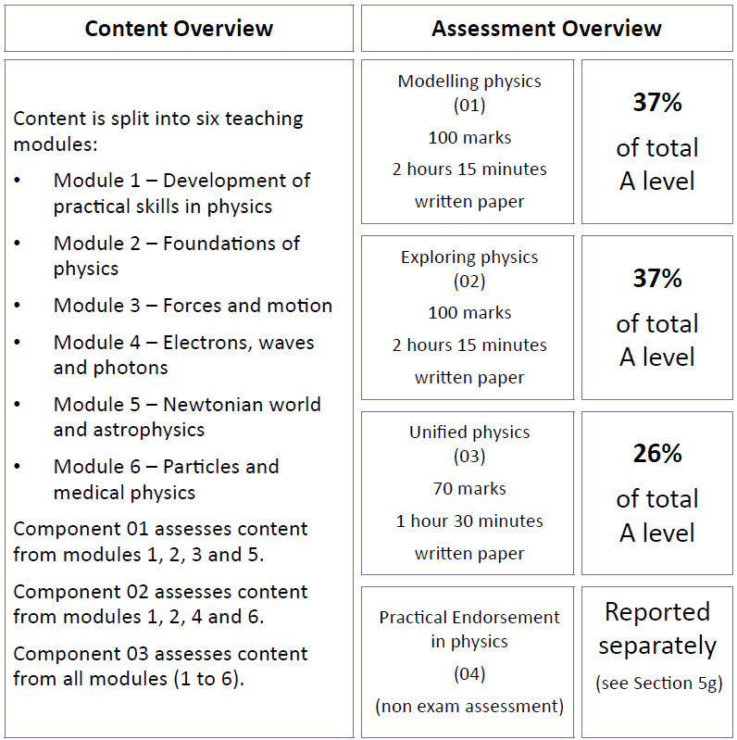
Subject works well with:
Chemistry, Mathematics, Computer Science, Product Design, Economics

Students go on to be:
Aerodynamicist, architect, research scientist, astronomer, engineering (biomedical, mechanical, electrical, chemical etc), computer modelling, energy analyst, meteorologist, medical physicist, radiographer, sports engineer, sports bio-mechanist, sports technologist.

Explore more at: https://www.stem.org.uk/secondary/careers/resources/science/physics

What do students say about the course?
“It’s really interesting to see how physics is used in the real world. You get a better appreciation for how much physics influences our day to day lives”

“The physics teachers are very supportive in and out of lessons. They really helped me build my confidence in the subject.”

“Studying Physics has enabled me to understand the fundamental concepts which underpin everything around us. Not only that but my problem solving, and mathematical skills have gotten much better.”

“It was good to do practicals in A level Physics where we take our time to gather data and analyse results. You feel like more of a scientist compared to GCSE.”
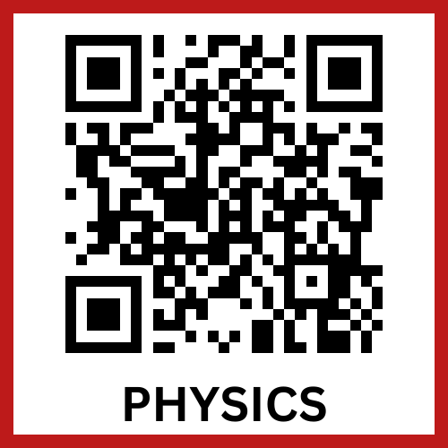
To see what our students have to say about this subject scan the QR code

