Subject and Exam Board: A-level Biology OCR A. Syllabus no. H420
Web link: https://www.ocr.org.uk/qualifications/as-and-a-level/biology-a-h020-h420-from-2015/
Minimum Entry Requirement at GSCE: Grade 6 or above in Biology or 7-7 or above in Combined Science and Grade 6 in Maths
Head of Subject: Mrs Tester
Course Description

OCR’s A Level in Biology A specification aims to encourage learners to:
- Develop essential knowledge and understanding of different areas of the subject and how they relate to each other.
- Develop and demonstrate a deep appreciation of the skills, knowledge and understanding of scientific methods.
- Develop competence and confidence in a variety of practical, mathematical and problem-solving skills.
- Develop their interest in and enthusiasm for the subject, including developing an interest in further study and careers associated with the subject.
- Recognise the value and responsible use of biology in society. Students will understand how society makes decisions about scientific issues and how the sciences contribute to the success of the economy and society.
- Prepare students for higher and other educational establishments and for professional courses which require candidates to have a knowledge of biology when admitted.
- Practical activities are embedded within the learning outcomes of the course to encourage practical activities in the classroom which contribute to the achievement of the Practical Endorsement. Practical areas covered include microscopy, dissection, sampling techniques, rates of enzymes reaction, colorimeter or photometer, chromatography or electrophoresis, microbiological technology, transport out of cells, qualitative testing, using data logger or computer modelling, measuring plant and animal responses and research skills.

What you will learn in Year 12 | What you will learn in Year 13
Module 1:  Development of practical skills in Biology.  Planning, implementing, analysis, and evaluation of practical skills.  Module 2: Foundations in biology  Cell structure, biological molecules, nucleotides and nucleic acids, enzymes, biological membranes, cell division, cell diversity and cellular organisation.  Module 3: Exchange and transport  Exchange surfaces, transport in animals and transport in plants  Module 4: Biodiversity, evolution and disease  Communicable diseases, disease prevention and the immune system, biodiversity, classification and evolution. | Module 1:  Development of practical skills in Biology  Planning, implementing, analysis and evaluation of practical skills.  Module 5: Communication, homeostasis and energy  Excretion, neuronal communication, hormonal communication, plant and animal responses, photosynthesis and respiration.  Module 6: Genetic, evolution and ecosystems  Cellular control, inheritances, genomes, cloning, biotechnology, populations, ecosystems and sustainability.

A-Level Exam Structure
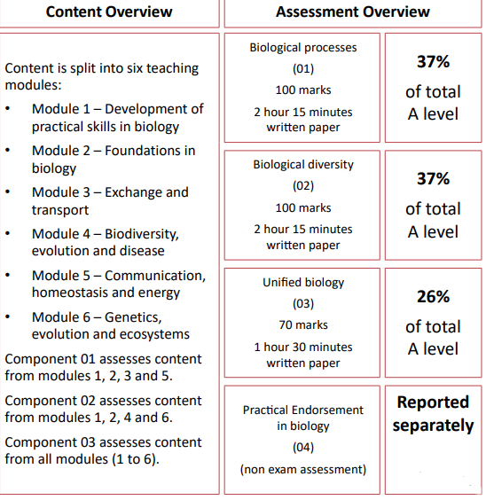
Subject works well with:
Chemistry and physical education.

Students go on to be:

Doctors, Zoologists, Ecologists, Sport scientists, Marine biologists, Optometrists, Neuroscientists, Dermatologists, Biochemists, Nutritionists, Physiotherapists and Veterinarians.

What do students say about the course?

“I enjoy A-level Biology especially learning all of the practical skills.” Preesha.
“Biology teachers at West Hatch are approachable and helpful, I really recommend coming here”. Stella.
“I like transport in plants.” Ishan.
“Human anatomy is intriguing.” Amrit.
“Biology is a hard subject but it is really interesting, I like communicable diseases”. Ria.
“I chose to study Biology because it gives a good insight into the complexity of life on Earth such as how the ecosystems thrive and the importance of each species depending on each other for survival.” Natalia.
“I enjoy Biology because it’s interesting to learn about the world we live in. Every class is fun and engaging and you build great bonds with the teachers”. Harvey.
“The practical side of the subject is interesting as you are given the opportunity to see the biological processes of life first-hand. You will also be offered a lot of support through your two years studying Biology at West Hatch.” Abbie.
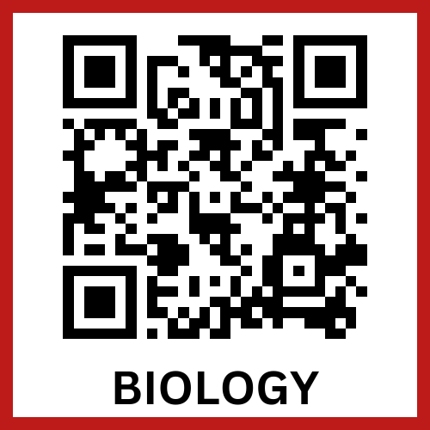
To see what our students have to say about this subject scan the QR code

