Subject and Exam Board: History OCR
Web Link: OCR A Level History A (H505) Specification
Minimum Entry Requirement: Grade 6 or above in History. If not taken at GCSE Grade 6 in another subject and Grade 5 in English
Head of Subject: Ms D Sterlini
Course Description

OCR History aims to enable students to:
- Develop their interest in and enthusiasm for history and an understanding of its intrinsic value and significance.
- acquire an understanding of different identities within society and an appreciation of aspects such as social, cultural, religious and ethnic diversity, as appropriate.
- Build on their understanding of the past through experiencing a broad and balanced course of study.
- Improve as effective and independent learners and as critical and reflective thinkers with curious and enquiring minds.
- Develop the ability to ask relevant and significant questions about the past and to research them.
- Acquire an understanding of the nature of historical study, for example that history is concerned with judgements based on available evidence and that historical judgements are provisional.
- Develop their use and understanding of historical terms, concepts and skills.
- Make links and draw comparisons within and/or across different periods and aspects of the past.
- Organise and communicate their historical knowledge and understanding in different ways, arguing a case and reaching substantiated judgements.

What you will learn in Year 12 | What you will learn in Year 13
Unit 1 Y113: Britain c.1930-1997 (Churchill)  - An in-depth study in the work of Churchill as a politician and war time leader to evaluate both his successes and failures. Then an analysis of the years which followed WW2 and how each government handled the trails and tribulations that modern Britian brought.  Unit 2 Y212: The American Revolution 1740-1796  - A study of how America moved from a British colony without representation to an independent and free United States. You will consider the impact of this on America and Britain and evaluate the importance of this key historical event. | Unit 3 Y319: Civil Rights in the USA 1865-1992  - A synoptic look at the importance of the Civil Rights movement in America. Analysing and evaluating key individuals and using historical interpretations to draw conclusions about the significance of this period of history.  Unit 4 Topic based essay (Coursework)  - An independent non-exam assessment where students can analyse and evaluate a topic of your own choice in order to draw conclusions and intervene in the historical argument. This unit requires you to draw on all of the skills acquired in unit 1-3 to create your own historical arguments.
A-Level Exam Structure
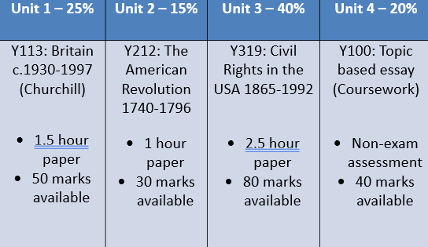

Subject works well with:

- Government and Politics
- Economics
- English Literature
- Business Studies
- Philosophy and Ethics
- Media Studies
- Sociology
- Maths/Science (To show variety of skills/knowledge)

Students go on to be:
- Lawyers
- Civil servants
- Accountants
- Archivists
- Local government
- Insurance brokers
- Marketing executives
- Teachers

What do students say about the course?

‘We have a blast while learning about the past.’ Inaya

‘Everyone in our history class is now perfect at winning at arguments.’ Maija

‘I feel prepared for University style research having study history A level.’ Aaron



To see what our students have to say about this subject scan the QR code

