Subject and Exam Board: Government and Politics Edexcel
Web Link: A level Politics - Specification (pearson.com)
Minimum Entry Requirement: Grade 6 in Government & Politics/History OR Grade 6 in another GCSE and Grade 5 in English
Head of Subject: Miss L Elliot
Course Description
The aims and objectives of this qualification are to enable students to:

• develop knowledge and an informed understanding of contemporary political structures and issues in their historical context, both within the United Kingdom (UK) and globally
• develop a critical awareness of the changing nature of politics and the relationships between political ideas, institutions and processes
• develop knowledge and an informed understanding of the influences and interests which have an impact on decisions in government and politics
• develop knowledge and an informed understanding of the rights and responsibilities of individuals and groups
• develop the ability to critically analyse, interpret and evaluate political information to form arguments and make judgements
• develop an interest in, and engagement with, contemporary politics.

What you will learn in Year 12 | What you will learn in Year 13
Paper 1 UK Politics  - You will look at democracy in the UK, how and why it operates as it does and questions whether changes could be made; for example, whether the voting age should be lowered to 16.  Paper 2 UK Government  - You will look at how the government runs the UK, how and why it operates as it does and questions whether changes could be made; for example, whether there are enough checks on the work of the Prime Minister. | Paper 3 US Government and Politics  - This paper looks at the functions of politics and government with the US system and then compares them to the UK so you can evaluate the effectiveness of each system.  Non-Core political ideologies  - Feminism (paper 2)  - Conservatism (paper 1)  - Socialism (paper 1)  - Liberalism (paper 1)
A-Level Exam Structure
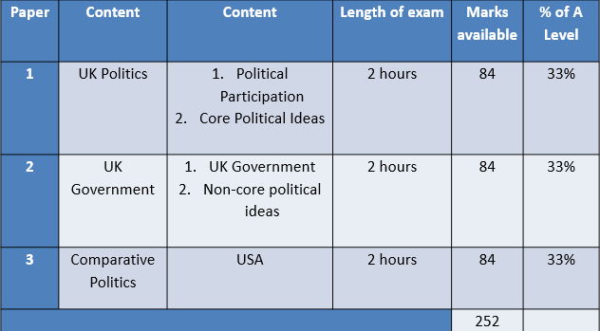

Subject works well with:
- History
- Economics
- English Literature
- Business Studies
- Philosophy and Ethics
- Media Studies
- Sociology
- Maths/Science (To show variety of skills/knowledge)

Students go on to be:
- Lawyers
- Civil servants
- Accountants
- Archivists
- Local government
- Insurance brokers
- Marketing executives
- Teachers

What do students say about the course?

‘It’s a really interactive subject which is linked with real life issues.’ Inaya

‘The class is really supportive of each other’ Edward

‘Debates are fun!’ Aadam

‘It’s a really interesting subject.’ Neslihan

‘The teachers are always there to help when you need it.’ Marcel


To see what our students have to say about this subject scan the QR code

