Young Carers Help lines and website Contact List



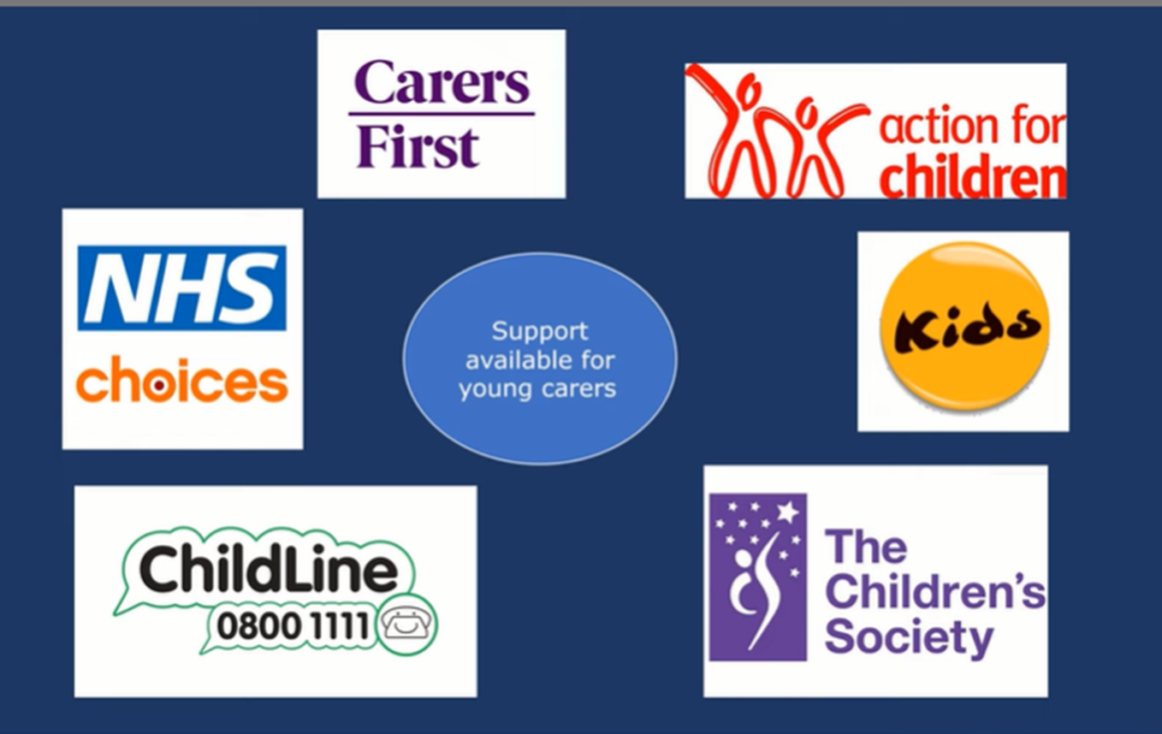
Kids
KIDS is a national charity, founded in 1970, that provides a wide range of services to disabled children, young people and their families in England. We support children from babies through to young adults, whatever their disability. Our services include: drop-in crèches and nurseries for the under 5s to youth clubs, short breaks and residential stays for young adults.

Website: https://www.kids.org.uk/Pages/Category/what-we-do

KIDS London: Telephone: 0207 359 3635


We fight for hope by deeply understanding the needs of young people and by supporting them through their most serious life challenges. We work with young people who have suffered years of abuse, who have run away from home or are struggling with mental health issues. We look out for young carers and those who are at risk of being groomed by gangs. We help refugees who have no one else to turn to in this country.

Website: https://www.childrenssociety.org.uk/
Tel: 03003037000

Action for children
Our support helps young carers come to terms with their parent's or other family member’s illness or condition. We teach them how to cope, and guide them to build positive relationships outside the family.
We help young carers plan for the future, by making sure they can access adult services when they’re 18.
Web:
https://www.actionforchildren.org.uk/our-work-and-impact/children-and-families/young-carers/

Carers First
Carers First works directly with and for carers to provide personalised information and advice. Making it easier for those caring for someone else to continue living their lives to the fullest.
Web:
https://www.carersfirst.org.uk/help-and-advice/topics/?selectedTags=Young%20carers

Helpline: 0300 303 1555
Email: hello@carersfirst.org.uk
Central office address: Michael Gill Building, Tolgate Lane, Strood, ME2 4TG

NHS Choices
If you're a young carer, friends and relatives are often the first people to turn to for help with problems. Talking things through with them can be really helpful.

Web:
https://www.nhs.uk/conditions/social-care-and-support-guide/support-and-benefits-for-carers/help-for-young-carers/

Childline
Web:
https://www.childline.org.uk/info-advice/

Call us free on 0800 1111

